EXP NO 3: Create A Simple Cloud Software Application For Property Buying & Rental Process (In Chennai City) Using Any Cloud Service Provider To Demonstrate Saas.

AIM:
To Create a simple cloud software application for Property Buying & Rental process (In Chennai city) using any Cloud Service Provider to demonstrate SaaS.

PROCEDURE:
step1: Go to zoho.com.
step 2: Log into the zoho.com.
step 3: Select one application step.
step4: Enter application name as property buying & rental.
step 5: Created new application as property buying & rental.
step 6: Select one form.
step 7: The software has been created.

Output:
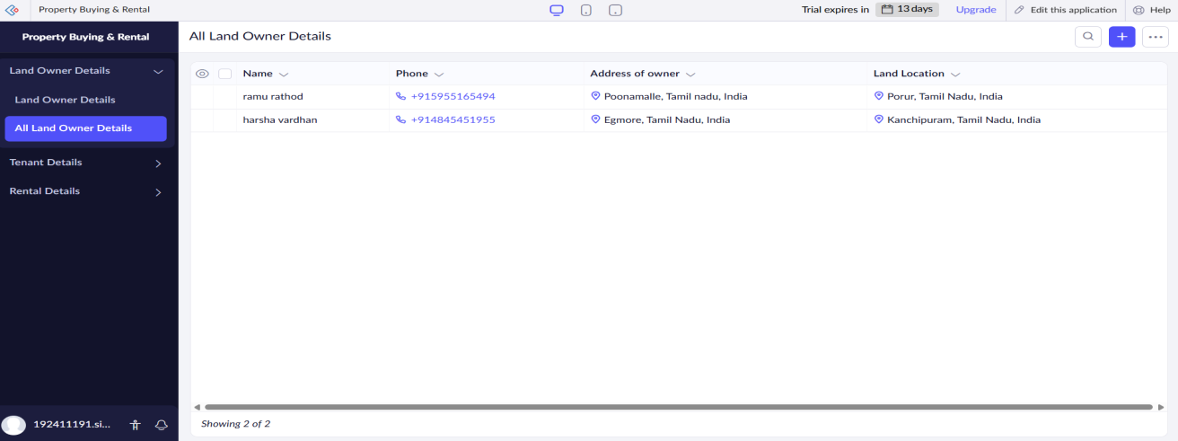
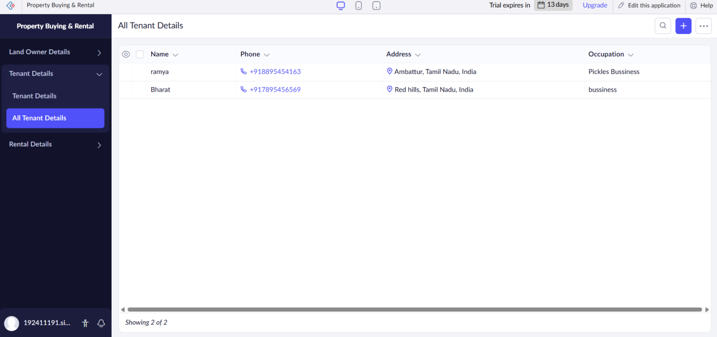

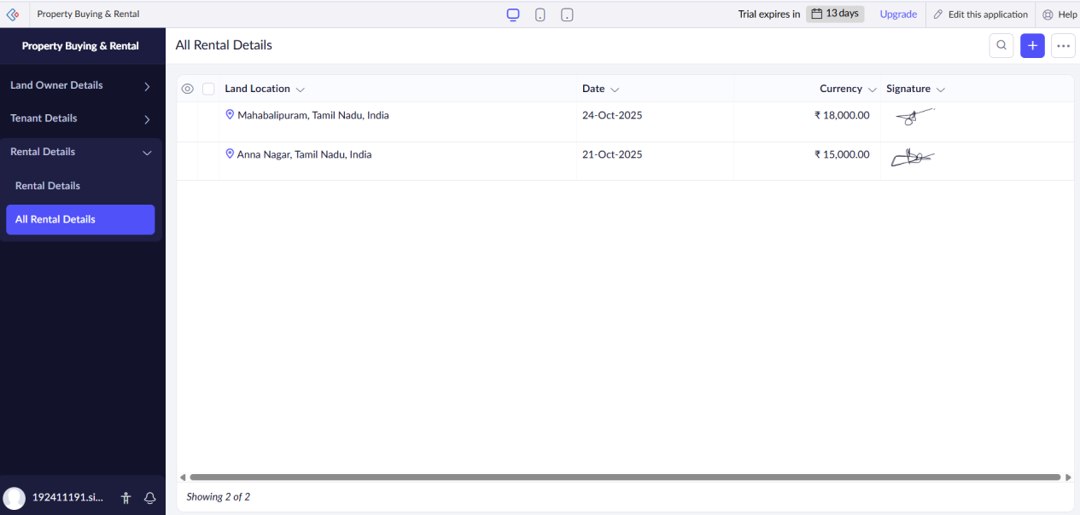

Results:
A simple cloud software application for Property Buying & Rental process (In Chennai city) using any Cloud Service Provider to demonstrate SaaS has been Successfully implemented.

